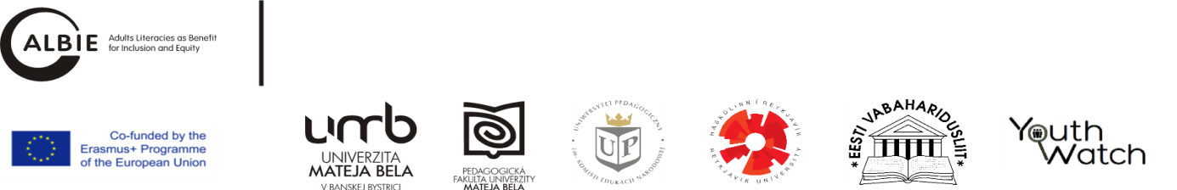
Transnational meeting 2, Krakow, 09. – 11.10.2017 (room 106N)
Project name: Adults Literacies as Benefit for Inclusion and Equity /ALBIE/
Project number: 2016-1-SK01-KA204-022586
Funded: Erasmus+ KA2 programme
Agenda

Day 1 /09.10.2017/ | Time | Topic | Topic | Provided by
 | All day long  16:00 – 17:00 | Arrival of participants,  Meeting of TNM2 executive team
 | 17:00 | Dinner  Introduction to agenda |  | UPKEN, Poland*
Day 2 /10.10.2017/
 | 8:30 – 9:00 | Participants registration |  | UPKEN, Poland
 | 9:00 – 9:30 | Welcome note  prof. dr hab. Katarzyna Potyrała - Vice Rector  prof. dr hab. Zofia Szarota – Head of Deparmenet social pedagogy and andragogy and Łukasz Tomczyk Head of Albie Poland |  | UPKEN, Poland
 | 9:30 – 10:00 | Summary of the project achievements |  | DA UMB, Barbora Vaněk
 | 10:00 – 10:30 | coffee break
 | 10:30 – 11:15 | Financial project agenda |  | UCIP UMB, Zuzana Kvetková
 | 11:15 – 12:15  15 minutes for each partner | Project partners presentations |  | RU, Iceland, Asrun Mattiasdótir  EESTI, Estonia, Tiina Jägger  YW, Slovakia, Viliam Michalovič  UPKEN, Poland, Lukasz Tomczyk
 | 12:15 – 13:15 | lunch
 | 13:15 – 13:30 | Presentation of project impact – Monograph Adults Literacies as Benefit for Inclusion and Equity. Reports on young adults being NEETs: Estonia, Iceland, Poland and Slovakia. |  | Lukasz Tomczyk
 | 13:30 – 17:30 |  | Individual financial consultation to partners /to financial managers/ | Project coordinator, Zuzana Kvetková
 | 13:30 – 14:30 | IO3 presentation of the outcomes + discussion |  | DA UMB, Barbora Bírešová, prof. Soňa Kariková
 | 14:30 – 15:30 | IO4 searching for universal model of educational programme vs. individual country needs + discussion |  | DA UMB, Martin Schubert  Project partners (IS, EE, PL, SK)
 | 15:30 – 16:00 | coffee break
 | 16:00 – 16:30 | Project quality indicators |  | DA UMB, Barbora Vaněk
 | 16:30 – 17:30 | Discussion on next steps (testing the educational program, short training of lecturers, open educational resource |  | Moderated by DA UMB
 | 17:30 | Wrap up, end of the day |  | UPKEN, DA UMB
 | 18:30 | Non formal meeting |  | UPKEN
Day 3 /11.10.2017/
 | 10:00 – 12:00 | Evaluation meeting of TNM2 executive team
 | All day long | Departure of participants

*at own costs of each project partner

